Artwork of Diana Magrann

Diana divides her time between being a doctor's wife, who makes the Dolan House available to fans, and being the manager of the lovely, "little girl with the beautiful high voice," Kathy Westmoreland. And if that isn't enough, in her spare time, Diana creates beautiful paintings of Elvis, some of which, are life-size, like the one pictured here.
When I asked Diana recently when she first became an Elvis fan, she explained it began the moment her older sister brought home a 45 rpm record of "Heartbreak Hotel." Later on, as a majorette and feature twirler in high school and college, she practiced to Elvis songs. She says it was her favorite way of staying in shape for years, and that one of her son's earliest memories of her is of her twirling the baton to "My Baby Left Me."
Diana continues her story with how she renewed her fascination for Elvis one night in 1985. She was watching the news with her husband John. It was the eighth anniversary of Elvis death. She explains how she still remembers turning to her husband and asking, "Why are people making such a fuss over him?" He’s been dead for eight years. That very night, Loving You came on TV. It was that night that Diana watched her very first Elvis movie. This time she turned to her husband and said, "Now I know what all the fuss is about."
It wasn't long after that night in 1985, that Diana put her landscape and wildlife paintings aside, as a new passion began and Elvis became the object of her paintings.
She tells how in the beginning, her paintings revolved around the a young blond Elvis, when he was so natural, and so open". Her paintings now involve a likeness of Elvis that ranges from age 29 to 38.
Diana's paintings are truly unique as she adds touches of clothing and gold chains to give them that wonderful three-dimensional look.
Diana’s paintings have won numerous awards at Graceland's annual Elvis Art Competition, including seven first place wins, with her life size Elvis in fringe being the first. Graceland has bought nine of her paintings. They added a "professional" category to the competition so she could continue to enter the contest after she turned professional, and restricted the entries to just one per category, after she took first, second and third, several years running.
Diana and her husband John reside in La Palma, California. They spend part of their time at 1266 Dolan drive at the house Elvis built for his dad Vernon. Diana and her husband, and their partner Bill McGuire, acquired the Dolan House in 1987.

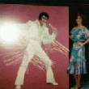 | 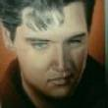 | 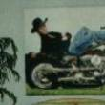 | 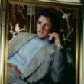  Lancaster, PA | 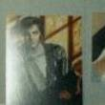
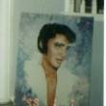 | 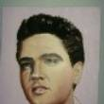

Diana sells originals as well as prints of her beautiful paintings. You can contact her at Diana
The copyright of the article Diana Magrann in Elvis Presley is owned by June Moore. Permission to republish Diana Magrann in print or online must be granted by the author in writing.

