Pallbearers
Tom Magrann IV, grandson
Tom Jones, nephew
Jeffrey Gibson, nephew
Jim Magrann, nephew
Brian Buchanan, nephew
Vincent McBride, nephew

IRISH BLESSING
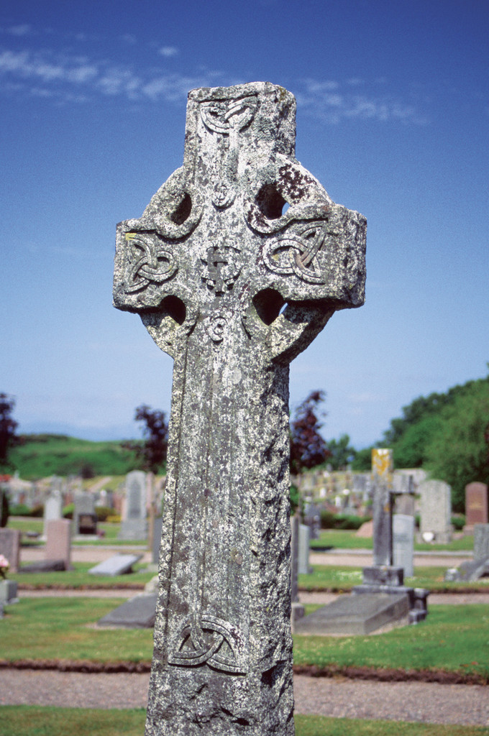
May the road rise up to meet you.
May the wind be always at your back.
May the sun shine warm upon your face.
And the rains fall soft upon your fields,
And until we meet again,
May God hold you in the palm of His hand.

FINAL RESTING PLACE
Holy Sepulcher Cemetery
Orange, California

THANK YOU
A very heartfelt thank you to all who made this celebration and every day
of Tom’s life so wonderful. Our family is touched by your love and your generosity. May God bless you all! -- The Magrann Family

There will be a reception at Eastlake Village Clubhouse
in Yorba Linda following the graveside services.

If you would like to make a memorial donation,
the family requests donations be sent to:

Heifer International
P.O. Box 8058
Little Rock, Arkansas 72203-8058
In Loving Memory

Thomas Joseph Magrann II
Loving Husband, Father, Grandfather, Brother, Friend

September 23, 1923 – January 5, 2008
MEMORIAL MASS
St. Martin de Porres Catholic Church
Yorba Linda, California
January 9, 2008 - 10:00 a.m.

Celebrant: Fr. Joseph Knerr
Altar Server: Ryan Brehparkem, friend
Cantor: Philip Parke
Pianist: James Post

Prelude
Here I Am, Lord

Gathering Song
On Eagle’s Wings

First Reading
Wisdom 3:1-6,9
Read by Thomas J. Magrann III, son

Responsorial Psalm

Psalm 24:1, 4, 7-9, 13-14
The Lord is my Light and my Salvation

Second Reading

2 Timothy 4:6-8

Read by Timothy Magrann, son

Gospel

John 14:1-6

Homily

Fr. Joseph Knerr

General Intercessions

Composed by the family and read by

Kelly Magrann, granddaughter

Royale Magrann, granddaughter

Meghan Magrann, granddaughter

Offertory Song

Be Not Afraid

Presentation of Gifts

Presented by

Molly Rose Magrann, granddaughter

Kyle Graves, grandson

Communion Songs

One Bread, One Body

Amazing Grace

Communion Meditation

Hail Mary, Gentle Woman

Eulogy

Thomas Jones, nephew

Closing Prayer Irish Blessing
Sandra Corder, niece

Poem ~ “My Old Man”
Composed by and read by Tracey Magrann, Daughter

Recessional Song
Danny Boy

